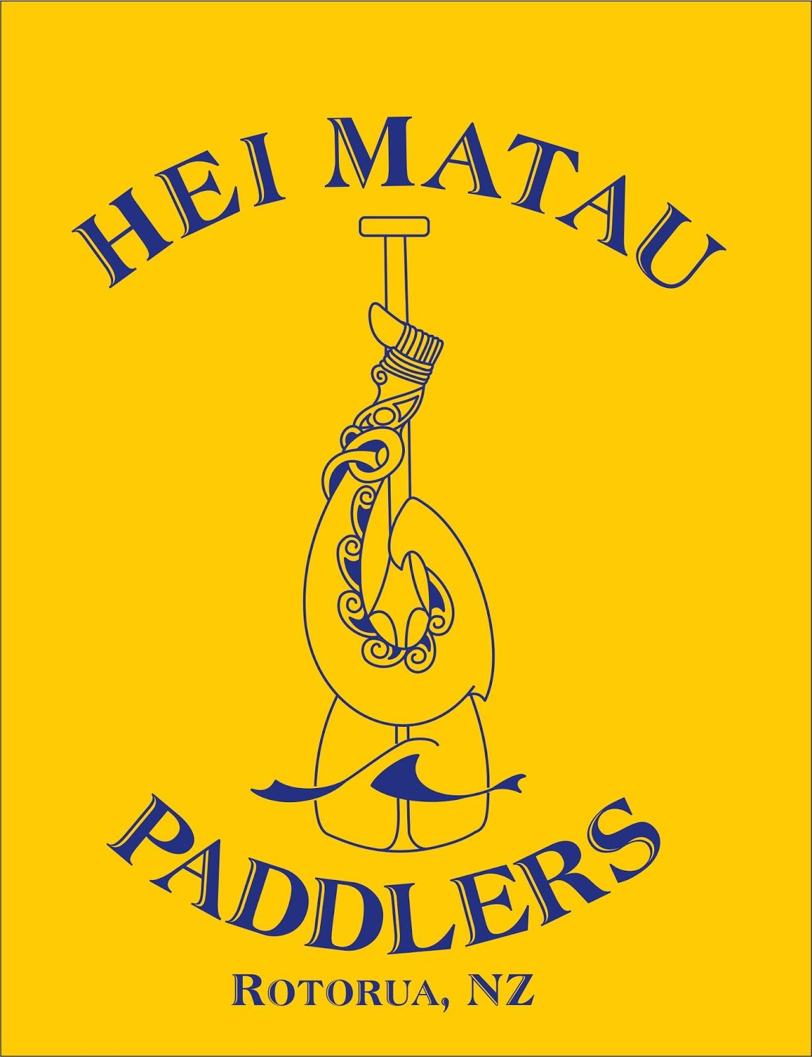
Hoea ki Mokoia W6 & W1 Race

Date: Saturday 30 March 2019
Venue: Rotorua Lakefront, ROTORUA
Enquiries contact: melrrika@gmail.com

Kaupapa

Long Distance race as a lead up for LDNs in April. Work in conjunction with NZ Secondary Schools, so if any of our Junior teams
would like to stay on and race, that would be great.

Races

This event will be open to Women, Men, Juniors and Novice paddlers. Teams racing in the novice category may have an experienced steerer onboard to assist them. Distances for the races will be between 10-15kms. All races are in water starts.

Hotaka - (Programme)

7.00am | Volunteers and Safety Boat Briefing
7.30am | Registration, rigging waka & safety checks | Secondary schools
8.00am | Karakia & Race Briefing
8.30am | Race start - 5kms | Secondary schools
8.40am | Race start - 15kms | W6 Mens
8.50am | Race start - 10kms | W1 Womens
9.30am | Race briefing & waka checks - 10km | Novice & Junior Race
10.15am | Race start - 10kms | Novice & Junior
11.00am | Waka checks & race briefing - 15km & 10km | W6 Womens & W1 Men
11.15pm | Race start - 15kms | W6 Womens
11.25am | Race start - 10kms | W1 Mens
1.30pm | Race briefing & waka checks - 15kms | Mixed Teams
1:45pm | Race start - 15kms | Mixed Teams
3.00pm | Prizegiving | All teams

Entries and Payments
Entries are online through Waka Ama NZ
Payment can be made (with TEAM Name as reference) to
HEI MATAU PADDLERS 06-0413-0365366-03
Please send through your intent to paddle by Saturday 23 March
via email to : melrrika@gmail.com
Mel Rika - 0272588874

Rules

- W6 canoes must have 2 bailers and 6 lifejackets and 2 spare paddle.
- All waka will have to pass a safety check and be marked before racing. Any boats not marked will not be permitted to race. (Refer to NKOA Rules for safety equipment requirements). NOTE: Buoyancy Aids/Tubes do NOT constitute a PFD.
- Junior Teams constitute actual J16 and J19 crews.
- All W6 waka must have a tow rope fitted to the waka. The rope must be at least 12mm diameter and a minimum length of 25 metres.
- All boats must have spray skirt available on the day. Race organiser’s reserve the right to make spray skirts compulsory if required.
- The Race Organisers have the discretion to cancel the race, refuse entry to crews for any reason related to safety of participants.
- All steerers and team captains must attend the race briefing.
- Should a waka require assistance during the race, the paddler in No.3 seat must hold their paddle up vertically so that an official rescue boat or any passing waka can render assistance.
- The lead waka will have right of way.
- On coming waka and craft must approach ‘port to port’ or ama to ama’.
- Competitors should dress appropriately for the conditions (including cooler conditions if required - wet suits, polypropylenes recommended) HI-vis is recommended
- The Race Director and his/her officials have absolute control of the event. They have the discretion to withdraw any competitor or waka which in their opinion is or will be endangering his/her or others safety.
- Race organisers will arrange official support boats, which will be marked accordingly.

Novice
- Novice paddlers are considered to be first time members, friends, partners etc. Novice races will continue if weather conditions are suitable. Novice teams must have an experienced steerer on board. PFD’s worn.

Food

There will be food available to purchase on the day. All paddlers will receive a free sausage sizzle. There will be a coffee cart at the event to purchase hot drinks.

Cost
W6 15km race Mens & Womens Teams $20 per paddler
W1 10km race Mens & Womens $20 per paddler
W6 10km race Novice & Junior Teams $15 per paddler
Those paddlers entering both W1 & W6 events , there will be an extra $10 fee ($30 for both races), same goes for entering two W6 races, cost will be $30 for both races.

Course Map

Junior & Novice Race and Mixed Teams will paddle out to the centre of Mokoia island, turn around the buoy and head back to shore, a distance of 10kms. PFD’s must be worn!!

Women’s and Men’s teams will race out around Mokoia Island going around from the right hand side, heading towards Owhata, then Hamurana, coming round past Ngongotaha then heading home, 15kms.

W6 REGISTRATION FORM

Club Name: ................................................................................

Team Name: ................................................................................

Contact Person: ................................................................................

Phone number: ................................................................................

Please circle the category your Team wishes to enter :

Open Men Master Men Senior Master Men Open Women Master Women

Senior Master Women Junior Men (10km) Junior Women (10km)

Junior Mixed (10km) Novice (10km) Mixed Master

Mixed Senior Master Open Mixed

Paddlers’ Names:
1) ............................................................. 4) .......................................................

2) ............................................................. 5) .......................................................

3) ............................................................. 6) .......................................................

COMPLETE WAIVER FOR ALL PADDLERS ON THE REVERSE SIDE OF THIS ENTRY FORM

Signed: Team Captain ..........................................................................

Club Official .............................................................................

WAKA AMA NEW ZEALAND EVENT WAIVER and AUTHORITY FORM

I declare that:
1. My accepted entry will not be transferred to another entrant.
2. In the event of any “act of God” conditions causing a cancellation of the event, my total entry fee is not transferable or refundable.
3. I acknowledge that there are risks involved with Waka Ama and fully realise the dangers of participating in an event such as this and fully assume the risks associated with such participation and my wellbeing during the event.
4. I understand and agree that situations may arise during the event, which may be beyond the immediate control of officials or organisers, and I must continually participate in a manner that does not endanger either myself or others.
5. Neither the organisers, the sponsors nor other parties associated with the event shall have any responsibility, ﬁnancial or otherwise, for any risk incident that might arise, whether or not by negligence, from any direct or indirect loss, injury or death that might be sustained by me or any other party directly or indirectly associated with me, from my intended or actual participation in the event or its related activities.
6. I authorise my name, voice, picture and information on this entry form to be used without payment to me in any broadcast, telecast, promotion, advertising, or any other way pursuant to the Privacy Act 1993.
7. I agree to comply with the rules, regulations and event instructions of the Hoea ki Mokia.
8. I consent to receiving medical treatment which may be advisable in the event of illness or injuries suffered during the event.
9. I confirm that I can swim 50 Metres/OR if I cannot swim 50 Metres I will wear a PFD during the race

Full Name | Date of Birth | Signature | Parent/Guardian  If competitor is under 18 waiver must be signed by Parent/Guardian

Date: 30 / 03 / 2019

